Print Stock Reports

Follow the below steps to print stock reports:
- Open Item Valuation. Navigation path: Inventory Control -> I/C Stock Control Reports -> Item Valuation
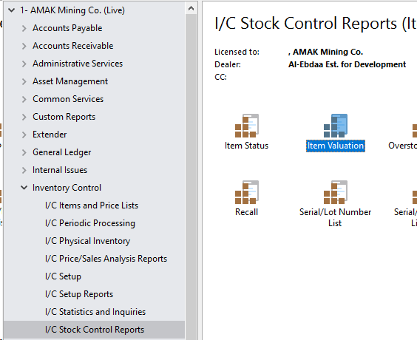

- Select the Item Valuation options as shown:
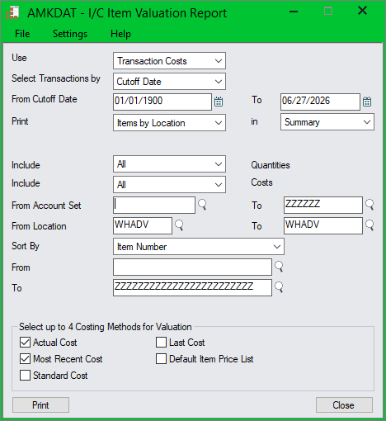

- Change the Print options as shown below:
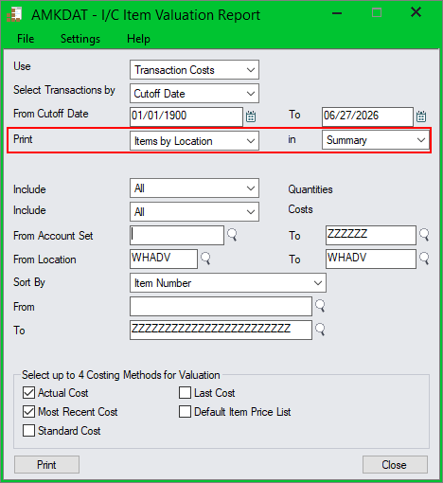

- Note location (warehouse) code:
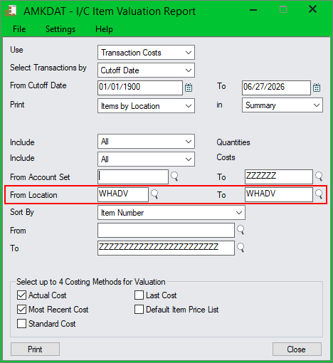

- Enter Item Number range here:
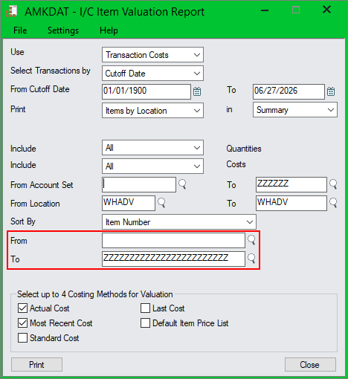

- You can also select by Category and other options as shown below:
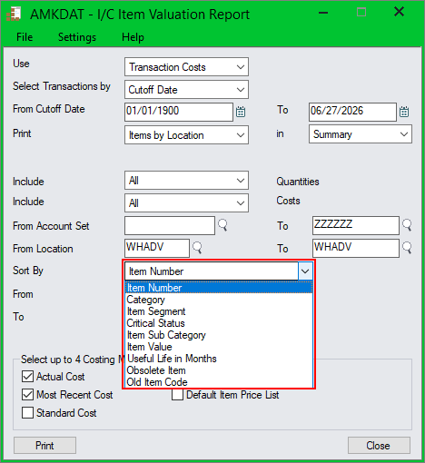

- Click Print and it will print a report similar to the one shown below:
